Nicholas Sammut

Dr. Mark Allison

CIS 525

**Lab Activity 1**

Screenshot of Emulator

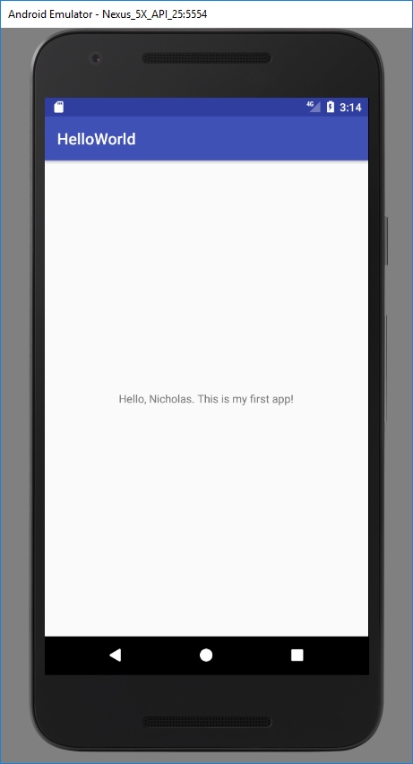

Activity .XML File

